Voices of the Grain Trade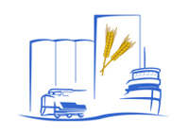

Oral History Recording Agreement Form

Interviewee: ____________________________________________________ First Middle Last

Date: __________________
DD MM YY

Sponsoring Organization: Friends of Grain Elevators

Interviewer: ________________________________________
First Last

Permission

I _________________________________________ consent to be interviewed for the Voices of the Grain Trade project. I understand that I am free to withdraw from the interview at any time or not respond to certain questions.

I agree that the recording of my interview and accompanying material may be made available for research at a location approved by the Friends of Grain Elevators, subject to any restrictions I may request.

I agree that the recording of my interview and accompanying material, may be quoted or shown in full or in part in the form of a transcript or in digital form on The Friends of Grain Elevators’ website or in its publications, subject to any restrictions I may request.

Restrictions
⁭ No restrictions.

⁭ My recording is closed for ______ years. During this period, the recording may be used only with my written permission

⁭ Other:

